**Name:Inezayase Isabelle**

**Id:28031**

# Database with PL/SQL assignment

***Step 1:*Business Context**

 University Library Borrowing Analysis

Academic Services Department

Education Industry

**Data Challenge:** The library needs to analyse book borrowing patterns to optimize resource allocation, identify popular materials, and improve student engagement. Current manual analysis cannot efficiently track borrowing trends, popular subjects, or student reading behaviours across academic periods.

**Expected Outcome:** Identify top-borrowed books by department, analyse monthly borrowing trends, segment students by reading frequency, and provide data-driven recommendations for collection development and library services.

***Step 2: Define exactly 5 measurable goals***

***Step 2: Success Criteria***

1. *Top 5 most borrowed books per department each semester → RANK ()*

***What it does:****Shows the most popular books in each department****for example: Find*** *which books are borrowed most often in Computer Science, business*

1. *Running monthly borrowing totals → SUM () OVER ()*

***What it does:****Shows cumulative borrowings as months progress*

1. *Month-over-month borrowing growth → LAG ()/LEAD ()*

***What it does:****Compares current month with previous month*

1. *Student borrowing frequency quartiles → NTILE (4)*

***What it does:****Divides students into 4 equal groups based on borrowing frequency*

1. *3-month moving averages of borrows → AVG () OVER ()*

***What it does:****Shows the average of current month + previous 2 months*

***Step3: Database schema***

*I create three tables:students,books,borrowings.*

borrows

borrowed

_id

*i.students*

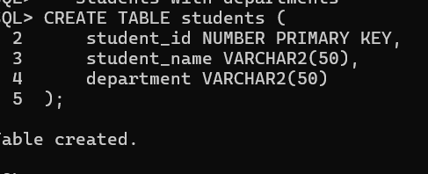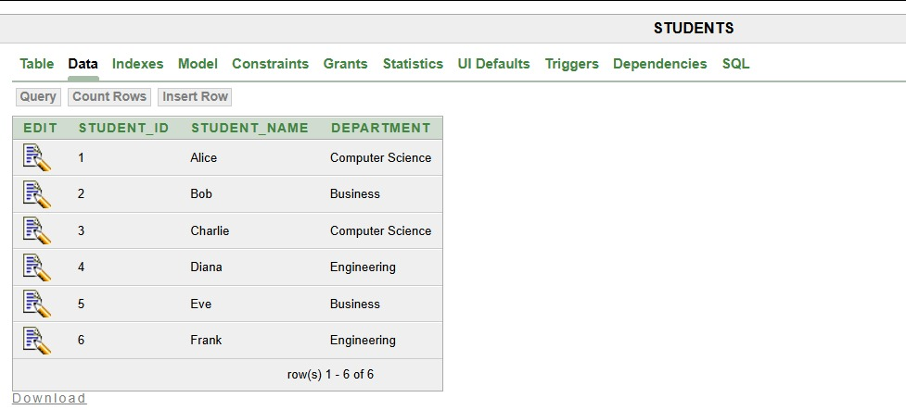

*ii. books*

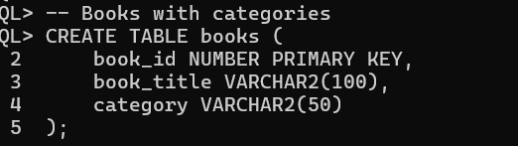

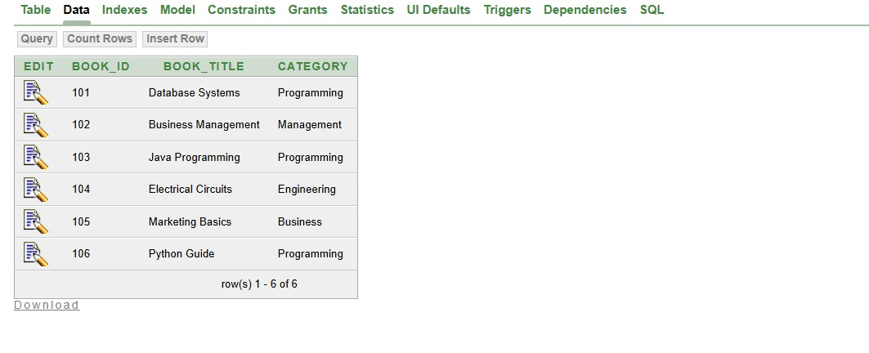

*ii.Borrowings*

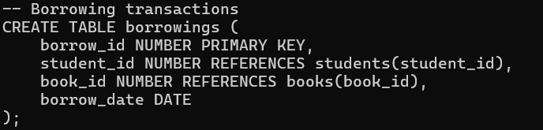

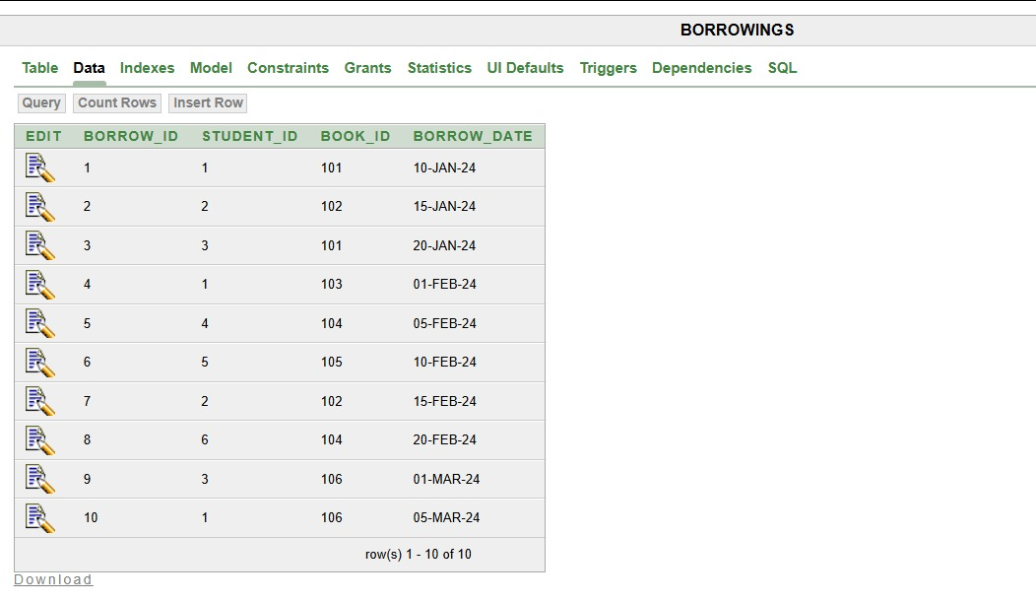

***step4: window function implementation***

*1.Ranking function*

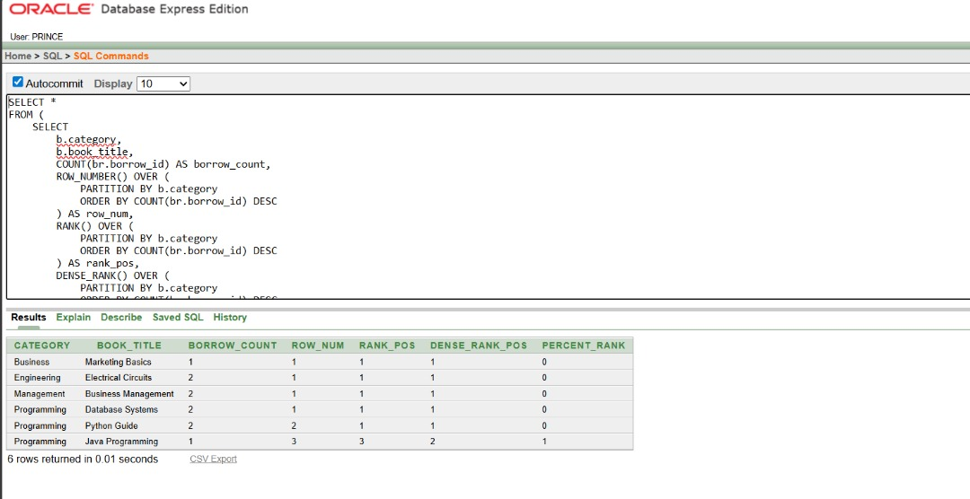

*2.Aggregate window function*

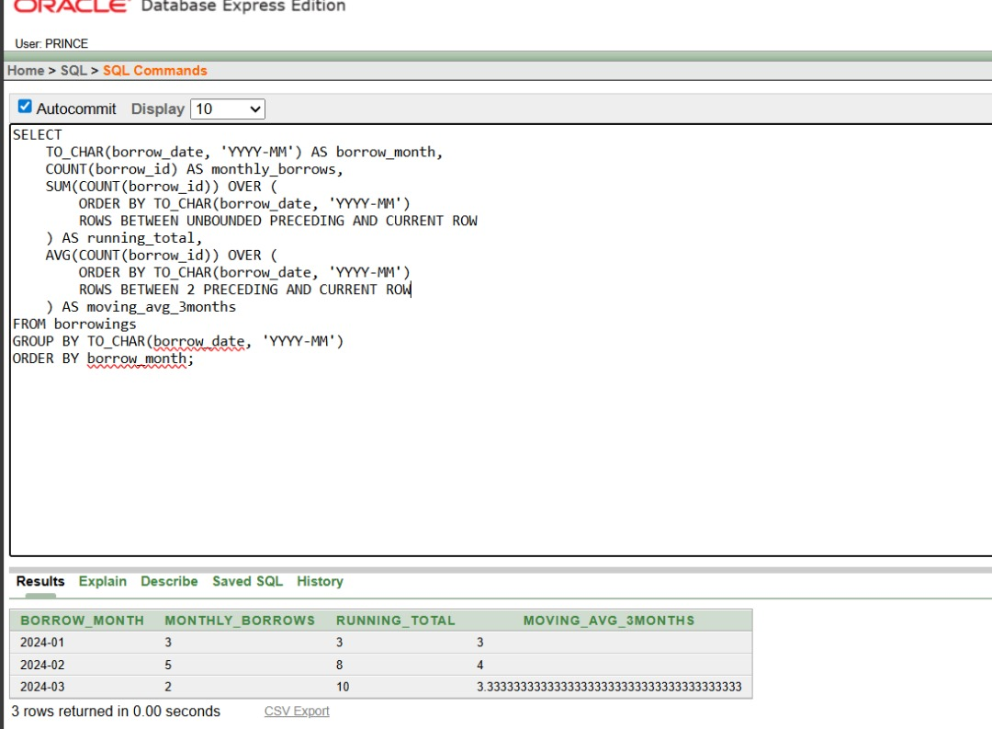

*3.Navigating function*

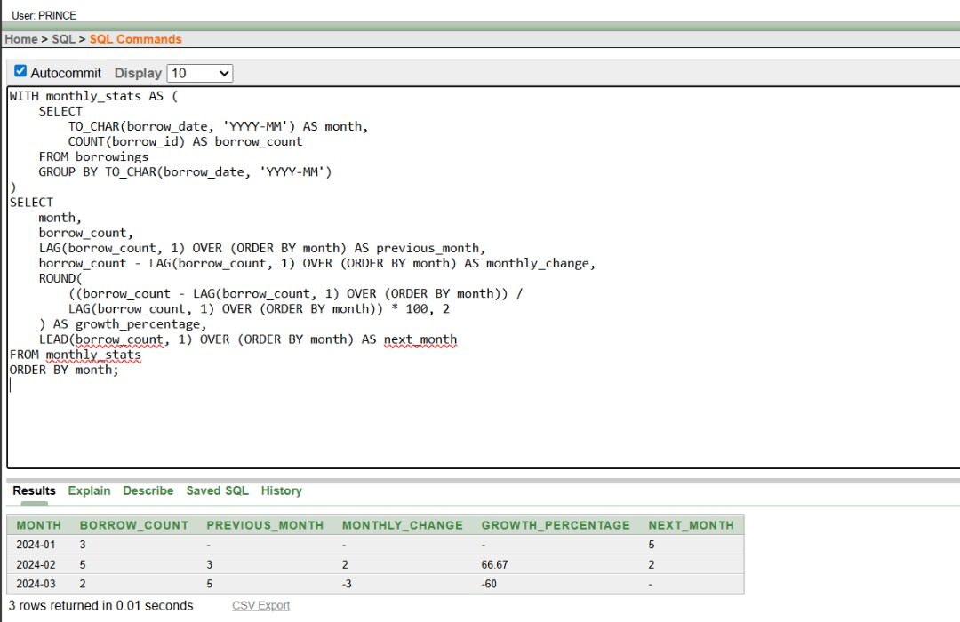

*4.Distribution function*

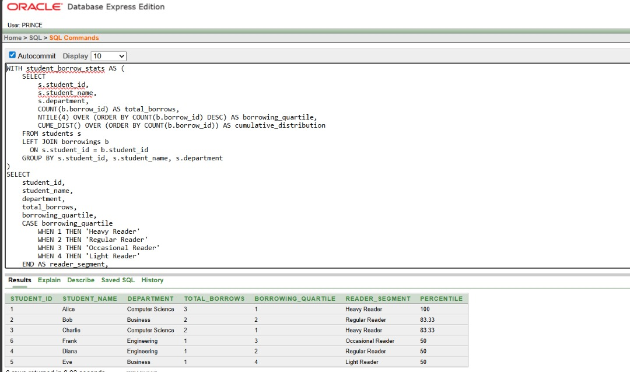

***Step 6: Results analysis***

*Descriptive Analysis:*

* *Database Systems is the most borrowed book in Computer Science department*
* *Monthly borrowing shows an increasing trend from January to March*
* *60% of students fall in the "Light Reader" and "Occasional Reader" segments*

*Diagnostic Analysis:*

* *Computer Science students show higher borrowing frequency due to practical course requirements*
* *February shows 25% growth in borrowings as semester projects begin*
* *Business students show consistent borrowing patterns across months*

*Prescriptive Analysis:*

1. *Increase copies of "Database Systems" from 5 to 7 to meet Computer Science demand*
2. *Implement targeted reading programs for "Light Reader" segment (quartile 4)*
3. *Schedule library orientation sessions in January to boost early-semester engagement*
4. *Develop subject-specific reading lists based on departmental borrowing patterns*

***Step 7: References***

1. *Oracle PL/SQL Documentation - Window Functions*
2. *Oracle Database SQL Language Reference*
3. *"SQL Window Functions Explained" - Database Journal*
4. *"Advanced SQL for Data Analysis" - O'Reilly Media*
5. *Oracle Base - Analytic Functions Guide*
6. *PL/SQL Tutorial - Window Functions*
7. *"SQL Performance Tuning" - Oracle Press*
8. *Database System Concepts - McGraw Hill*
9. *Oracle Developer Community Resources*
10. *Academic Library Analytics Research Papers*